Application Form
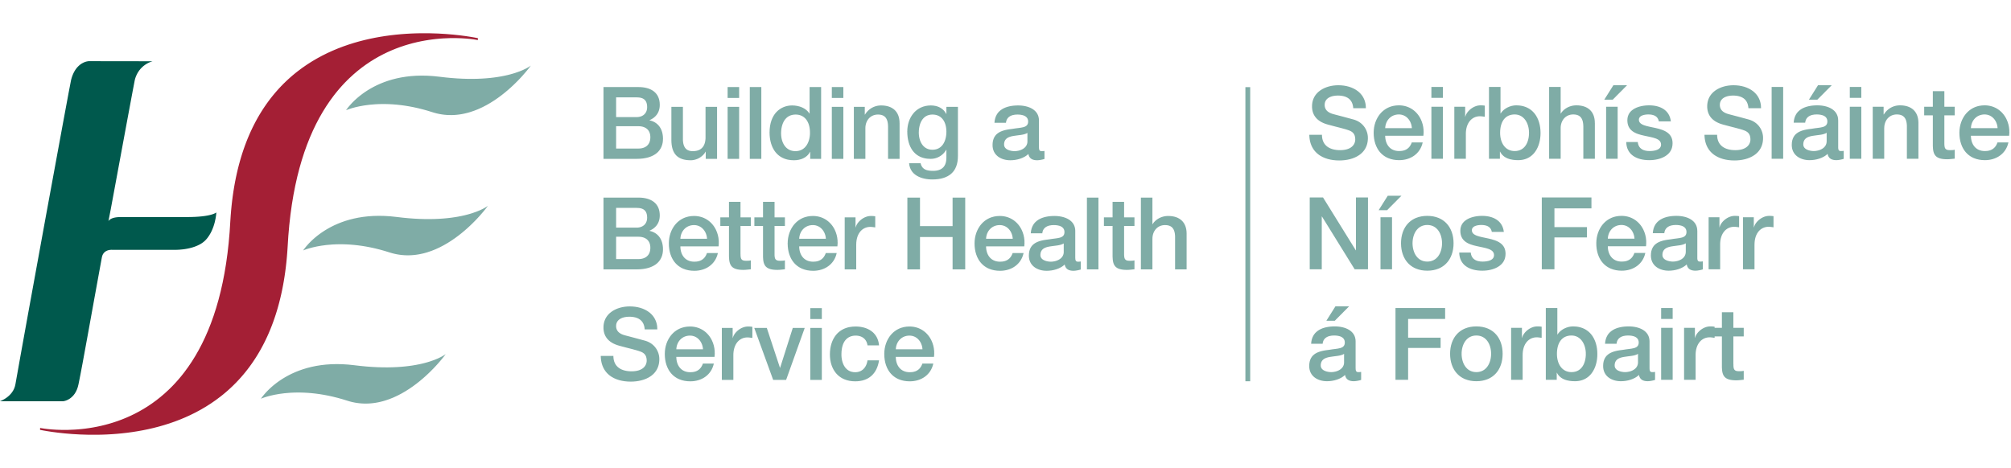
‘Men in the Middle’
- exploring men’s health and wellbeing at middle-age

I would like to apply for a place at the ‘Men in the Middle’ Men’s Health Symposium. I understand that this event will ...

- take place on Thursday 15th March 2018;
- begin with registration / refreshments at 9.30am and finish at 3.30pm;
- be held in Dr Steevens' Hospital, Dublin 8.

If I am offered a place, I confirm that I am willing and able to attend the whole of this event.

Participation in the Symposium is free. However, as demand for places is likely to exceed the number available, I understand that if I am allocated a place - and my circumstances change - I must contact the organisers as soon as possible (but by no later than 5.00pm on Wednesday 7th March 2018) to cancel my booking. This will allow my place to be offered to a ‘waiting list’ candidate. If I fail to do this, I agree to pay a cancellation fee of €25.00 to help to offset the costs associated with my registration.

My contact details are ...

Please complete all sections which are appropriate to you. Each person requesting a place must fill out a separate form.

Name
Position
Organisation
Address
Eircode / Post Code
Phone Number
Email Address
Any Special Access or Dietary Requirements

Please complete and return this Application Form by email attachment to symposium@mhfi.org as soon as possible. The deadline for applications is Friday 2nd March 2018.

Please Note: Places at this event are extremely limited, and every effort will be made to ensure that delegates come from a diverse range of backgrounds and locations. However, priority will also be given to the order in which applications are received. When all places are allocated, a ‘waiting list’ will operate.

